



**Semester Project**

**Intelligent Virtual Characters for Next-Generation AR Experiences**

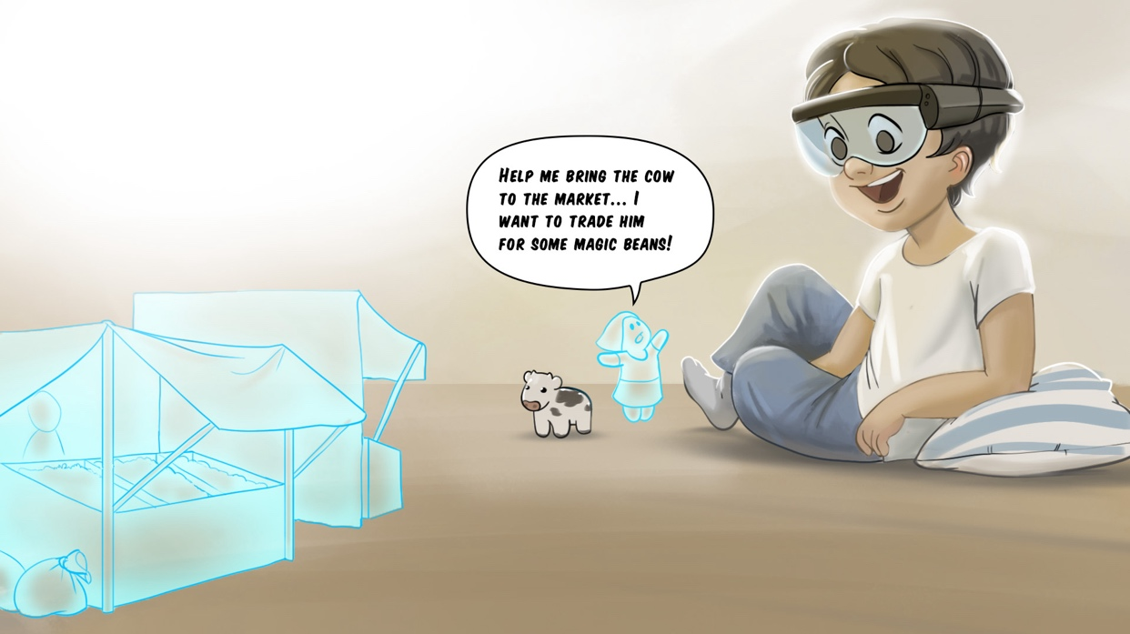

# Project Description

DisneyResearch|Studios (DRS) is collaborating with the Game Technology Center (GTC) and the Media Technology Center (MTC) at ETH Zurich to develop tools for creating intelligent characters, which inhabit augmented reality (AR) environments. The final goal of this collaboration is to have autonomous virtual characters that can navigate and interact with the real environment. One aspect of this research is the challenge of giving the character intelligence to take action according to a story, a narrative goal or a user action. A lot of research has been conducted in interactive stories. However, most of this work focuses on pre-defined environments. This is not directly applicable to AR worlds where the environment is subject to constant change and might not be known initially. In this thesis the student will investigate related research and develop methods to allow virtual characters to reason about appropriate actions within their environment. Depending on the interest of the student, there are opportunities to explore topics including character knowledge, multi-character coordination, and natural language communication with the user.

# Skills

* Proficiency in C#
* Interest or experience with AI and ML topics
* Experience with Unity3D is a benefit, but not required

# Remarks

A written report and an oral presentation conclude the thesis. The thesis will be overseen by Prof. Robert W. Sumner, Steven Poulakos (DRS) and Manuel Braunschweiler (ETH). Please contact Steven Poulakos ([steven.poulakos@disneyresearch.com](mailto:steven.poulakos@disneyresearch.com)) for more information.